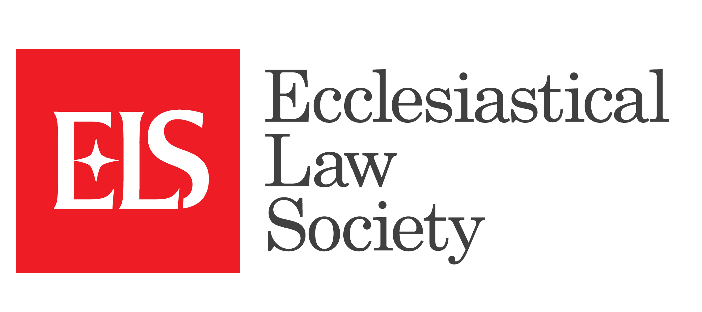
TRUSTEES’ REPORT 2025
The Ecclesiastical Law Society is a Charitable Incorporated Organisation (registered charity no 1181002) whose registered office is at 1 The Sanctuary, London SW1P 3JT.
The Trustees of the Charity for this reporting period were:
Lee Coley (Chair)
The Rt Rev’d Martin Warner (Vice Chair)
The Rev’d Paul Benfield (Treasurer until 14th May)
The Ven Moira Astin (Treasurer from 14th May)
Paul Barber
Rebecca Cattermole (co-opted 14th July)
Frances Godden
The Rev’d Sam Maginnis
Ola Olajide
The Rev’d Canon Neil Patterson (until 14th May)
The Rev’d Christopher Smith

The objects of the CIO as stated in our Constitution are:
The objects (“Objects”) of the CIO are:
To promote education in ecclesiastical law for the benefit of the public including in particular but not exclusively:
- the clergy and laity of the Church of England;
- those who hold authority or judicial office in, or practise in the ecclesiastical courts of, the Church of England;
- and students and teachers of ecclesiastical law.
The Trustees are pleased to report that during the calendar year 2025 these objects were furthered in all of the activities and meetings of the Society and the Trustees wish to record their thanks to all those, Officers, members and service providers for their work in maintaining the life and witness of the Society. Given the programme for the weekend conference, Nicaea Received, the AGM was held separately and electronically on 14th May. Forty-two members attended and a further 21 presented their apologies. At the meeting The Rev’d Paul Benfield stood down as Treasurer and The Ven Moira Astin was elected to replace him. There were two nominations for Charity Trustees, both returning for another term of service – Paul Barber and Frances Godden.
The meeting received the annual accounts of the Charity which had been independently examined and these, with the Treasurer’s report, are appended at the end of this report. The Society relies almost entirely on its members for its income. During this reporting period the Charity received some sponsorship from Wrigleys, Stone King and Birketts, to whom the Trustees express their grateful thanks.
The Trustees met on four occasions in 2025. A major subject on the agenda of the first two meetings was to finalise the detail of the forthcoming weekend Conference Nicaea Received: 1700 years of Canons, Councils and ecumenism which was held from 20th to 22nd June 2025 in Chichester. The Conference was acclaimed by all who attended as being a most successful and challenging ecumenical event.
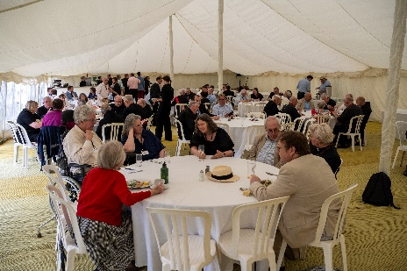
Being the Ecclesiastical Law Society, when we planned a conference on the impact of the Council of Nicea on the church over the 1700 years since it met, the focus was not on the Creed that bears its name but on the Canons which were agreed, and the very process of Christians meeting and discussing faith.
And so about 60 of us met in Chichester in the glorious surroundings of the Cathedral and the Bishop’s Palace to ourselves receive from the wisdom of the wider church. Our first keynote speaker was the Roman Catholic theologian Professor Myriam Wijlens who reflected on how the meeting at Nicea still influences how the Roman Catholic Church gathers synodically.
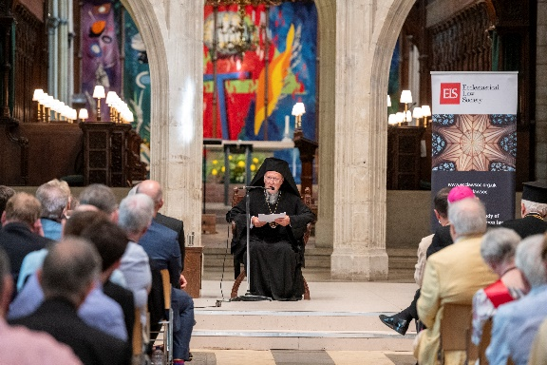
We also heard from an Anglican expert as The Rt Revd Dr Christopher Cocksworth shared with us from his own experience as well as his reflection on the way in which today in the Church of England we mirror the close relationship Constantine had with the church of his day as he spoke on ‘The Monarch, the common witness of the Church and the godly constitution of the State’.
But for many of us the highlight was hearing from His All-Holiness Bartholomew, Ecumenical Patriarch on how the Nicean Canons still play a part in the life of the Orthodox church.
Together with sharing food and coffee and the discussion in seminars it was a rich event with much to take away to continue to ponder on, and it gave us the chance to not just talk about ecumenism but to reflect on our common roots ecumenically.
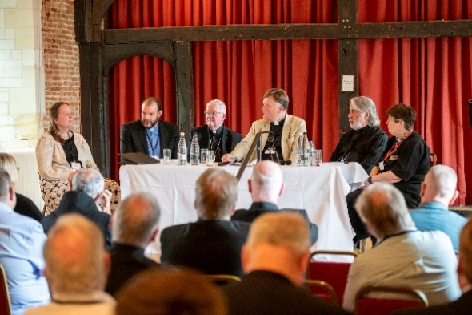
The Conference dominated our activity in the period covered by this report and the governance structure review group has not met. The group will reconvene in the coming year.
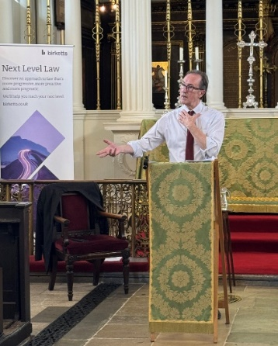
In addition to the Weekend Conference already referred to, a lecture programme was delivered with both in person and virtual events. The London Lectures were at the Grosvenor Chapel. We are grateful to them for their hospitality and to the lecturers.
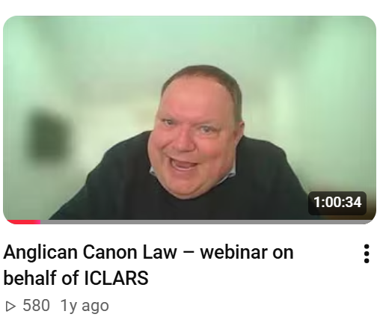
The training committee events have continued to prove popular with members and non-members. All training events this year took place on Zoom. The regular monthly “Bitesize Ecclesiastical Law” online seminars continued with guests speaking to the Rt Revd Moira Astin and the Revd Russell Dewhurst on a variety of introductory topics about the law of the Church of England. The themes addressed this year have included 'What is a registrar?', 'What is a chancellor?' and 'What is a PCC'?' Each is half an hour long with a 20 minute presentation followed by questions. The presentation is subsequently available on our YouTube channel. The Trustees record their thanks to all members of the training committee and to others who have assisted in these tasks.
The ELS was very pleased to host 12 March 2025 a webinar on Anglican canon law in collaboration with the International Consortium for Law and Religion Studies (ICLARS): this featured Professor Norman Doe KC, the Right Reverend Dr Vicentia Refiloe Kgabe, the Venerable Alan Perry, and the Worshipful Professor Mark Hill KC. Recordings of all of these can be seen on the Society’s YouTube channel, along with a recording of the Northern Province lecture by Peter Collier KC on “Safeguarding and the Law”.
The Trustees are also grateful to all the volunteers who offer to assist them in the work of the charity. We record our ongoing thanks to the section editors of the Journal and to its Editor, Ben Harrison. This is our flagship publication and we continue to work closely with CUP to guarantee its production and distribution. The Rev’d Russell Dewhurst and the Rev’d Stephen Coleman delivered teaching in canon law at several Theological Education Institutions of the Church of England, presenting the ELS course ‘Canon Law for the Newly-Ordained.’ The course is updated each year and is always enthusiastically received by those about to begin their ordained ministry.
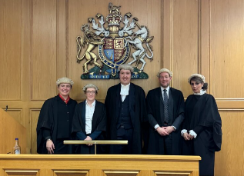
The ELS again collaborated with the Inner Temple in an annual Ecclesiastical Moot Competition by providing a generous cash prize to the winner. A similar competition has begun at Nottingham University and the Trustees are delighted to be able to work with a member to support this initiative.
The Society’s Newsletter, edited by Frances Godden, has been distributed regularly to members via email. Frances wishes to keep this publication fresh and accessible and, in order to do so, will be grateful to receive contributions and comments.
The composition of the Executive team has changed during the year. This was necessitated by the appointment of The Rev’d Russell Dewhurst as Archdeacon of Hastings. The Trustees record their gratitude to him for all he has contributed and wish him well in the new ministry. The Trustees also congratulate Moira Astin on her appointment as Bishop of Crediton. They thank all those whose time and talent have been employed in furthering the aims of the Society in the past year. We look forward to developing the scope of our work in the coming year.

